MAHARASHTRA STATE BOARD OF TECHNICAL EDUCATION

GOVERNMENT POLYTECHNIC, THANE.



# MICRO PROJECT

## Academic year: 2020-2021

TITLE OF PROJECT:NOTES TAKING WEB APP USING JS

Program: Computer Engineering Code: CO5I

Course: Client Side Scripting Course code: 22562

Name of Guide: Prof. Kanchan Salunkhe-Bagde

**Group Details**

|  |  |  |  |
| --- | --- | --- | --- |
| **Sr.**  **No.** | **Students Name** | **Enrollment**  **No.** | **Roll No.** |
| 1. | Pallavi Uttam Dongare | 1801160073 | 22 |
| 2. | Kalpita Vilas Birhade | 1801160075 | 24 |
| 3. | Hameed Karim Mulani | 1801160110 | 40 |

**Part- A**

**Title of Project: - NOTES TAKING WEB APP USING JS**

1. **Aims of the micro-project:-**
2. In this project, we can add notes as we required and delete note whenever we want.
3. To learn about JavaScript.
4. And we stores your important notes safely.
5. **Course outcomes:-**
6. Use required JavaScript to make the functionality web app.
7. Learn the logic of taking Notes in local Storage of user.
8. **Proposal Methodology:-**
9. In this project, we can add notes as we required and delete note whenever we want, this will create using JavaScript, Html and CSS, Bootstrap for Responsive UI.
10. Use JS functionality e.g., Event Handling and more.
11. And we can search notes with specific Keyword functionality.
12. **Resources Required:-**

|  |  |  |  |  |
| --- | --- | --- | --- | --- |
| **Sr. No.** | **Name of resources** | **Specification** | **Quantity** | **Remark** |
| 1. | Computer System | Windows 10 | As required |  |
| 2. | Web Browse | Chrome | As required |  |

1. **Action plan:-**

|  |  |  |  |  |
| --- | --- | --- | --- | --- |
| **Sr. No.** | **Details of activity** | **Plan start date** | **Plan ended date** | **Name of team members** |
| 1. | Planning |  |  | Pallavi Dongare |
| 2. | Coding |  |  | Kalpita Birhade |
| 3. | Report |  |  | Hameed Mulani |

Part –B

**Micro project report**

**Title of micro project- Notes Taking Web App Using JS**

1. **Rationale:-**

JavaScript is limited featured client side programming language. JavaScript runs at the client end through the user’s browser without sending message back and forth to the server. It is widely used by the web developers to do things such as build dynamic web pages, respond to events, create interactive forms, validate data that the visitor enters into a form, control the browser etc. this course helps student to create highly interactive web pages using these features.

1. **Aims/benefits of micro project:-**
2. To learn about JavaScript.
3. And we stores your important notes safely.
4. In this project, we can add notes as we required and delete note whenever we want.
5. **Course outcomes addressed:-**
6. Create interactive web pages using program flow control structure.
7. Implement arrays and functions in Java script.
8. **Literature review:-**
9. Search some data form reference book.
10. Implements skill of client site scripting.
11. Search some kind of information of notes taking app.
12. **Actual methodology followed:-**
13. We surfed on internet to achieve information about various web app.
14. We read books to understand of Client Site Scripting and JavaScript.
15. We tried to coding & then we run the code and sorted some errors.
16. After collecting all the information we needed, we made a detailed report based on our research and coding.
17. Then, we submitted our report to our guide.
18. **Recourses required:-**

|  |  |
| --- | --- |
| **Sr. no.** | **Name of resources/materials** |
| 1. | Text book of client side scripting (22519) |
| 2. | Laptop with internet |

1. **Output of micro projects:-**
2. **Code:**

//website.html

//1st file

<!DOCTYPE html>

<html lang="en">

<head>

<meta charset="UTF-8">

<meta name="viewport" content="width=device-width, initial-scale=1.0">

<meta http-equiv="X-UA-Compatible" content="ie=edge">

<title>Notes App</title>

<link rel="stylesheet" href="https://stackpath.bootstrapcdn.com/bootstrap/4.3.1/css/bootstrap.min.css"

integrity="sha384-

ggOyR0iXCbMQv3Xipma34MD+dH/1fQ784/j6cY/iJTQUOhcWr7x9JvoRxT2MZw1T" crossorigin="anonymous">

</head>

<body>

<nav class="navbar navbar-expand-lg navbar-dark bg-dark">

<a class="navbar-brand" href="#">Magic Notes</a>

<button class="navbar-toggler" type="button" data-toggle="collapse" data-target="#navbarSupportedContent"

aria-controls="navbarSupportedContent" aria-expanded="false" aria-label="Toggle navigation">

<span class="navbar-toggler-

icon"></span>

</button>

<div class="collapse navbar-collapse" id="navbarSupportedContent">

<ul class="navbar-nav mr-auto">

<li class="nav-item active">

<a class="nav-link" href="#">Home <span class="sr-only">(current)</span></a>

</li>

</ul>

<form class="form-inline my-2 my-lg-0">

<input class="form-control mr-sm-2" id="searchTxt" type="search" placeholder="Search" aria-label="Search">

<button class="btn btn-outline-success my-2 my-sm-0"

type="submit">Search</button>

</form>

</div>

</nav>

<div class="container my-3">

<h1>Welcome To Magic Notes</h1>

<div class="card">

<div class="card-body">

<h5 class="card-title">Add a note</h5>

<div class="form-group">

<textarea class="form-control" id="addTxt" rows="3"></textarea>

</div>

<button class="btn btn-primary" id="addBtn">Add Note</button>

</div>

</div>

<hr>

<h1>Your Notes</h1>

<hr>

<div id="notes" class="row container-fluid"> </div>

</div>

<script src="https://code.jquery.com/jquery-3.3.1.slim.min.js"

integrity="sha384-q8i/X+965DzO0rT7abK41JStQIAqVgRVzpbzo5smXKp4YfRvH+8abtTE1Pi6jizo"

crossorigin="anonymous"></script>

<script src="https://cdnjs.cloudflare.com/ajax/libs/popper.js/1.14.7/umd/popper.min.js"

integrity="sha384-UO2eT0CpHqdSJQ6hJty5KVphtPhzWj9WO1clHTMGa3JDZwrnQq4sF86dIHNDz0W1"

crossorigin="anonymous"></script>

<script src="https://stackpath.bootstrapcdn.com/bootstrap/4.3.1/js/bootstrap.min.js"

integrity="sha384-JjSmVgyd0p3pXB1rRibZUAYoIIy6OrQ6VrjIEaFf/nJGzIxFDsf4x0xIM+B07jRM"

crossorigin="anonymous"></script>

<script src="js/app.js"></script>

</body>

</html>

//2nd file

//app.js

console.log("Welcome to notes app. This is app.js");

showNotes();

// If user adds a note, add it to the localStorage

let addBtn = document.getElementById("addBtn");

addBtn.addEventListener("click", function(e) {

let addTxt = document.getElementById("addTxt");

let notes = localStorage.getItem("notes");

if (notes == null) {

notesObj = [];

} else {

notesObj = JSON.parse(notes);

}

notesObj.push(addTxt.value);

localStorage.setItem("notes", JSON.stringify(notesObj));

addTxt.value = "";

// console.log(notesObj);

showNotes();

});

// Function to show elements from localStorage

function showNotes() {

let notes = localStorage.getItem("notes");

if (notes == null) {

notesObj = [];

} else {

notesObj = JSON.parse(notes);

}

let html = "";

notesObj.forEach(function(element, index) {

html += `

<div class="noteCard my-2 mx-2 card" style="width: 18rem;">

<div class="card-body">

<h5 class="card-title">Note ${index + 1}</h5>

<p class="card-text"> ${element}</p>

<button id="${index}"onclick="deleteNote(this.id)" class="btn btn-primary">Delete Note</button>

</div>

</div>`;

});

let notesElm = document.getElementById("notes");

if (notesObj.length != 0) {

notesElm.innerHTML = html;

} else {

notesElm.innerHTML = `Nothing to show! Use "Add a Note" section above to add notes.`;

}

}

// Function to delete a note

function deleteNote(index) {

// console.log("I am deleting", index);

let notes = localStorage.getItem("notes");

if (notes == null) {

notesObj = [];

} else {

notesObj = JSON.parse(notes);

}

notesObj.splice(index, 1);

localStorage.setItem("notes", JSON.stringify(notesObj));

showNotes();

}

let search = document.getElementById('searchTxt');

search.addEventListener("input", function(){

let inputVal = search.value.toLowerCase();

// console.log('Input event fired!', inputVal);

let noteCards = document.getElementsByClassName('noteCard');

Array.from(noteCards).forEach(function(element){

let cardTxt = element.getElementsByTagName("p")[0].innerText;

if(cardTxt.includes(inputVal)){

element.style.display = "block";

}

else{

element.style.display = "none";

}

// console.log(cardTxt);

})

})

1. **Output:**

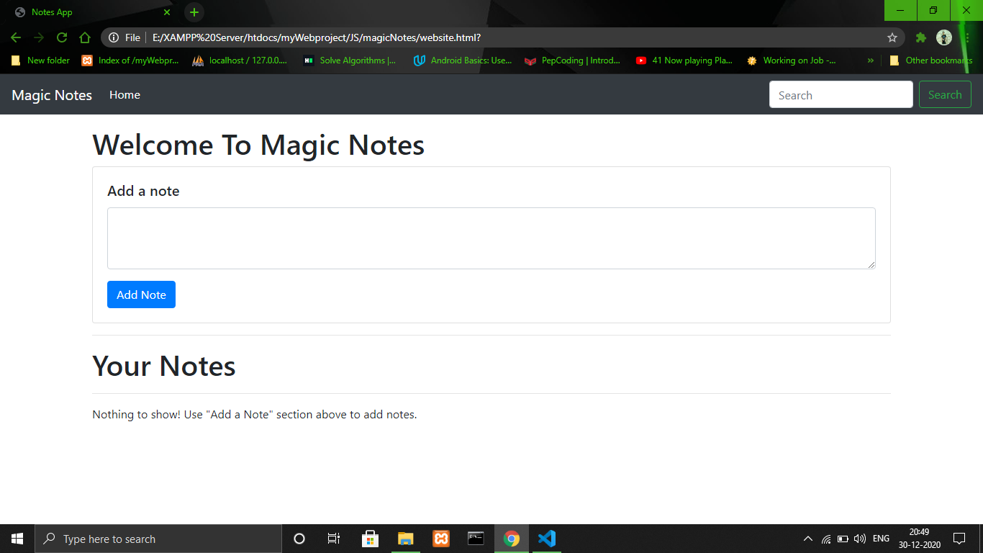



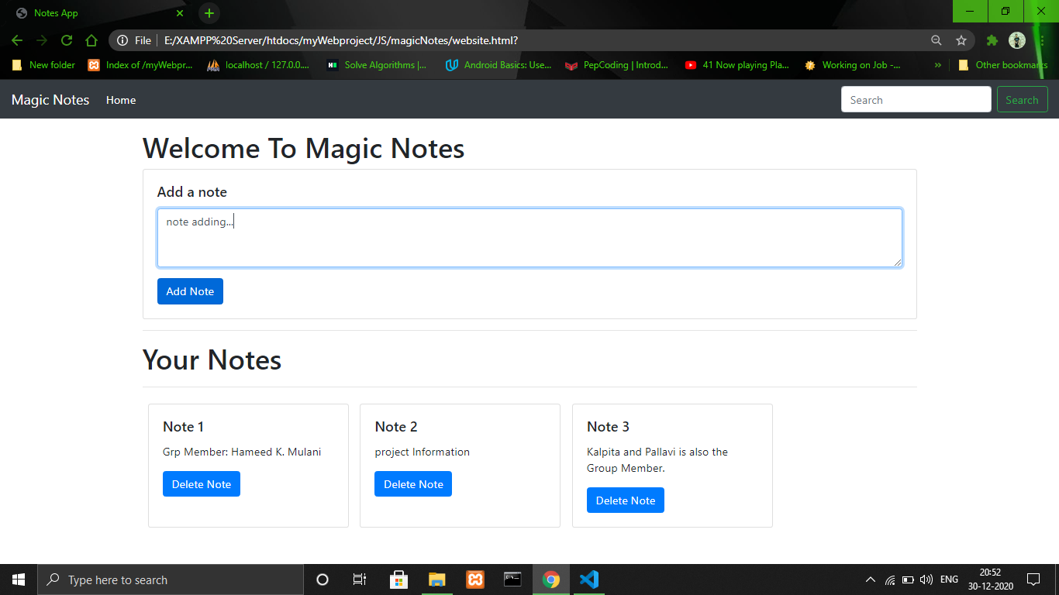

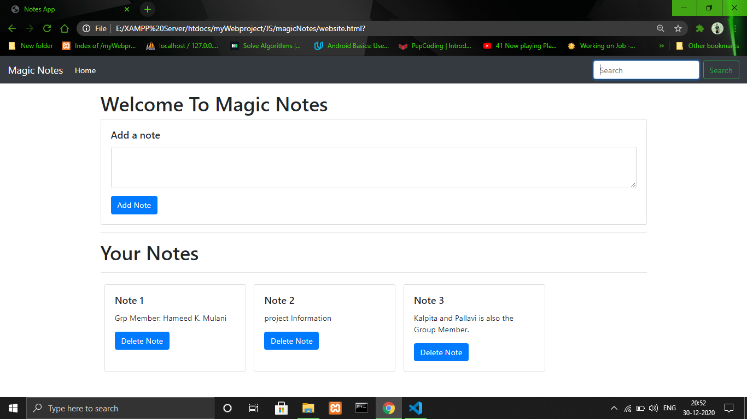

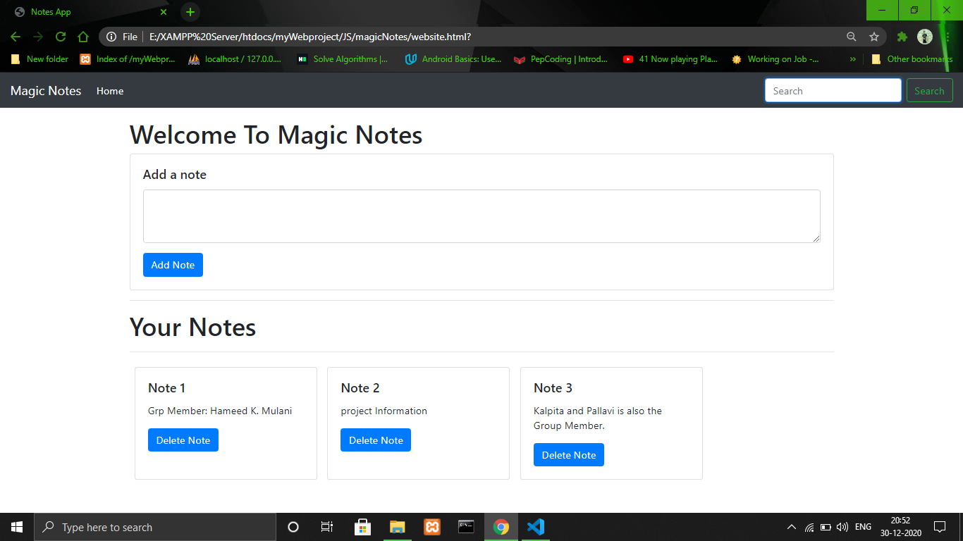

1. **Applications of the micro projects:-**
2. This micro-project can help students to save files and notes.
3. Students can also get to learn about the CSS and JS by referring to our micro-project.